* **KPIs**

1. **Total Revenue**

SELECT SUM(total_price) AS Total_Revenue from pizza_sales



1. **Average Order Value**

SELECT SUM(total_price) / COUNT(DISTINCT order_id) AS Avg_Order_Value FROM pizza_sales



1. **Total Pizza Sold**

SELECT SUM(quantity) as Total_Pizza_Sold from pizza_sales

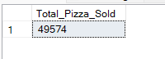

1. **Total Orders Placed**

SELECT COUNT(DISTINCT order_id) AS Total_Orders from pizza_sales



1. **Average Pizza Per Order**

SELECT SUM(quantity)/COUNT(DISTINCT order_id) AS Avg_Pizza_Per_Order from pizza_sales

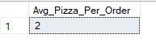

1. **Average Pizza Per Order Casted**

SELECT CAST(CAST(SUM(quantity) AS DECIMAL(10,2)) /

CAST(COUNT(DISTINCT order_id) AS DECIMAL(10,2)) AS DECIMAL(10,2)) AS Avg_Pizza_Per_Order from pizza_sales

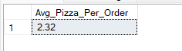

* **Charts**

1. **Trend of orders placed in the week / Daily Trend**

SELECT DATENAME(DW, order_date) AS ORDER_DAY, COUNT(DISTINCT ORDER_ID) AS NUM_OF_ORDERS

FROM pizza_sales

GROUP BY DATENAME(DW, order_date)

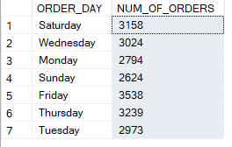

1. **Monthly Trend**

SELECT DATENAME(MONTH, order_date) AS ORDER_MONTH, COUNT(DISTINCT order_id) AS NUM_OF_ORDERS

FROM pizza_sales

GROUP BY DATENAME(MONTH, order_date)

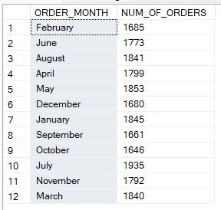

1. Percentage of Pizza Category Sales

SELECT pizza_category, SUM(total_price)*100 / (SELECT SUM(total_price) from pizza_sales) AS PCT

from pizza_sales

GROUP BY pizza_category

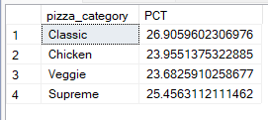

1. Percentage of Sales by Pizza Size

SELECT pizza_size,CAST( SUM(total_price) AS decimal(10,2) ) AS Total_Price, CAST(SUM(total_price)*100 / (SELECT SUM(total_price) from pizza_sales) AS DECIMAL(10,2)) AS PCT

from pizza_sales

GROUP BY pizza_size

ORDER BY PCT DESC

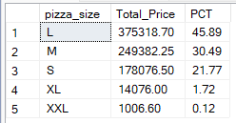

1. Top 5 Pizza by Revenue

select TOP 5 pizza_name, sum(total_price) AS Total_Revenue from pizza_sales

group by pizza_name

order by Total_Revenue DESC

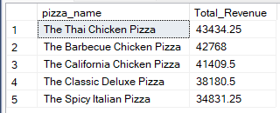

1. Bottom 5 Pizza by revenue

select TOP 5 pizza_name, sum(total_price) AS Total_Revenue from pizza_sales

group by pizza_name

order by Total_Revenue

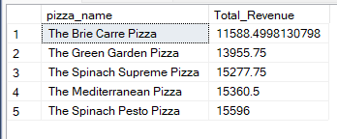

1. Top 5 Pizza by Quantity

select TOP 5 pizza_name, sum(quantity) AS Total_Quantity from pizza_sales

group by pizza_name

order by Total_Quantity desc

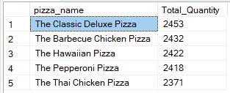

1. Top 5 Pizza by Orders

select TOP 5 pizza_name, COUNT (DISTINCT order_id) AS Total_Orders from pizza_sales

group by pizza_name

order by Total_Orders desc

